The Wealth of Nations

26-04-2023

Data Visualization

Microsoft excel and Tableau

Iram Saeed

justit.co.uk

Contents

Policies and Procedures to Work with Data 3

The Wealth of Nations 4

Data of ‘The Wealth of Nations’ 4

Responsibility toward data as Data analyst: 5

Excel: GDP Tasks 6

1. Password Protected Workbook 6

2. Highlighting and change the data in £ 8

3. *Turning the GDP sheet into table* 13

5. Chart; Rank, Country and GDP 19

6. Edit the Chart. 21

a) Add title 21

b) Add X-axis and Y-axis labels 23

c) Make Chart Visually Appealing 24

7. Move the Chart to new Sheet and Named it 26

8. TOP 20 Countries 29

9. Bar Chart 33

10. Colouring 35

# Policies and Procedures to Work with Data

When working with data, there are several policies that should be followed to ensure that the data is used appropriately, and that privacy and security concerns are addressed. Here are some policies that should be adhered to:

**Data Privacy**: It is important to ensure that data is used in compliance with applicable privacy laws and regulations. This includes obtaining the necessary consents and permissions, and ensuring that data is not used in a way that violates the privacy of individuals.

**Data Security**: Data should be protected from unauthorized access, disclosure, or modification. This includes using appropriate security measures to safeguard data, such as encryption, firewalls, and access controls.

**Data Quality**: It is important to ensure that data is accurate, complete, and reliable. This includes ensuring that data is properly collected, processed, and stored, and that it is validated and verified before it is used.

**Data Retention**: It is important to ensure that data is retained for only as long as necessary, and that it is securely disposed of when it is no longer needed. This includes ensuring that data is properly archived and backed up, and that it is deleted or destroyed in a secure manner.

**Data Ethics**: It is important to ensure that data is used in an ethical and responsible manner. This includes ensuring that data is used for legitimate purposes, and that it is not used in a way that discriminates or causes harm to individuals or groups.

**Data Governance**: It is important to establish clear policies and procedures for the management and use of data. This includes establishing clear roles and responsibilities, ensuring that data is properly documented and managed, and that appropriate oversight and accountability mechanisms are in place.

Overall, adherence to these policies will help to ensure that data is used in a way that is ethical, responsible, and secure, and that it benefits individuals and society as a whole.

# The Wealth of Nations

"The Wealth of Nations" is a book written by Adam Smith, which was first published in 1776. It is considered one of the foundational works of modern economics, and it covers a wide range of topics related to economics, such as the division of labour, the role of markets in promoting economic growth, and the importance of free trade.

In "The Wealth of Nations," Smith argued that a free market economy, in which individuals pursue their own self-interest and are guided by the "invisible hand" of market forces, would lead to the most efficient allocation of resources and the greatest economic growth. He also criticized the mercantilist policies of his time, which involved the government controlling trade and accumulating precious metals, and argued that free trade would benefit all nations involved.

Overall, "The Wealth of Nations" had a significant impact on the development of economic thought and continues to be studied and debated by economists and policymakers today.

## Data of ‘The Wealth of Nations’

Here you can find the link of data of ‘The Wealth of Nations’.

<https://justit831.sharepoint.com/:x:/s/DataAnalyticsProgramme-NewStandards/EVK1dsCfWvZMpvJzG9QaQk8B1nxx7hYR0KtGfbzJauf94g?e=CR1LFE>

Police:

When working with data related to "The Wealth of Nations," it is important to adhere to the following policies:

Respect Intellectual Property: As "The Wealth of Nations" is a copyrighted work, it is important to respect intellectual property rights when working with data related to its concepts and theories. This includes obtaining necessary permissions and citing sources appropriately.

Ensure Data Accuracy: Data related to the concepts and theories presented in "The Wealth of Nations" should be accurate and reliable. It is important to verify data sources and ensure that data is properly validated before it is used.

Avoid Misinterpretation: It is important to ensure that the concepts and theories presented in "The Wealth of Nations" are properly understood and interpreted. Misinterpretation or misuse of the data could lead to inaccurate conclusions and potentially harmful outcomes.

Use Ethical Considerations: When working with data related to the concepts and theories presented in "The Wealth of Nations," it is important to consider ethical implications. For example, some interpretations of the book have been criticized for promoting individualism and neglecting social welfare concerns.

Ensure Data Security: As with any data, data related to the concepts and theories presented in "The Wealth of Nations" should be protected from unauthorized access, disclosure, or modification.

Overall, adhering to these policies is important to ensure that data related to "The Wealth of Nations" is used appropriately, accurately, and ethically. It helps to ensure that the conclusions drawn from the data are reliable and informative and that decisions based on the data are socially responsible and beneficial to all stakeholders.

## Responsibility toward data as Data analyst:

As a data analyst, it is important to be aware of rules and regulations because working with data comes with a great deal of responsibility. Analyzing and interpreting data can have significant consequences, whether it is used to inform business decisions, public policy, or scientific research. Here are a few reasons why it is important to be aware of rules as a data analyst:

* **Compliance**: Many industries and organizations are subject to rules and regulations that govern the collection, use, and storage of data. As a data analyst, it is important to be aware of these rules to ensure that you are in compliance and that you are not putting the organization at risk.
* **Ethics:** Data can be used to influence people and make decisions that impact individuals and society as a whole. As a data analyst, it is important to be aware of ethical considerations when working with data to ensure that you are making decisions that are fair and just.
* **Accuracy:** As a data analyst, your job is to provide accurate and reliable insights based on data. Being aware of rules and regulations can help you to ensure that you are working with high-quality data and that your analyses are accurate and reliable.
* **Security:** Data breaches and cyber attacks are a growing concern for organizations. As a data analyst, it is important to be aware of rules and regulations related to data security to ensure that you are taking the necessary steps to protect sensitive information.

Being aware of rules and regulations is important for data analysts because it helps to ensure that data is being used responsibly, accurately, and securely. It also helps to prevent legal and ethical issues that can arise from non-compliance.

# Excel: GDP Tasks

## Password Protected Workbook

1. First click on review tab. Then select the ‘Protect and Share Workbook’ from ribbon.

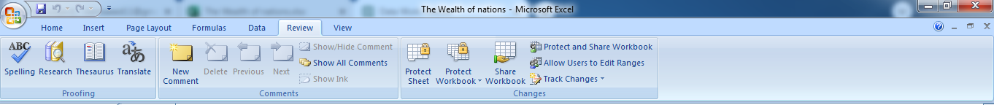

1. By clicking on ‘Protect and Share Workbook’, small window will pop up with heading Protect Shared Workbook. Select the option ‘Sharing with track changes’ and put password.

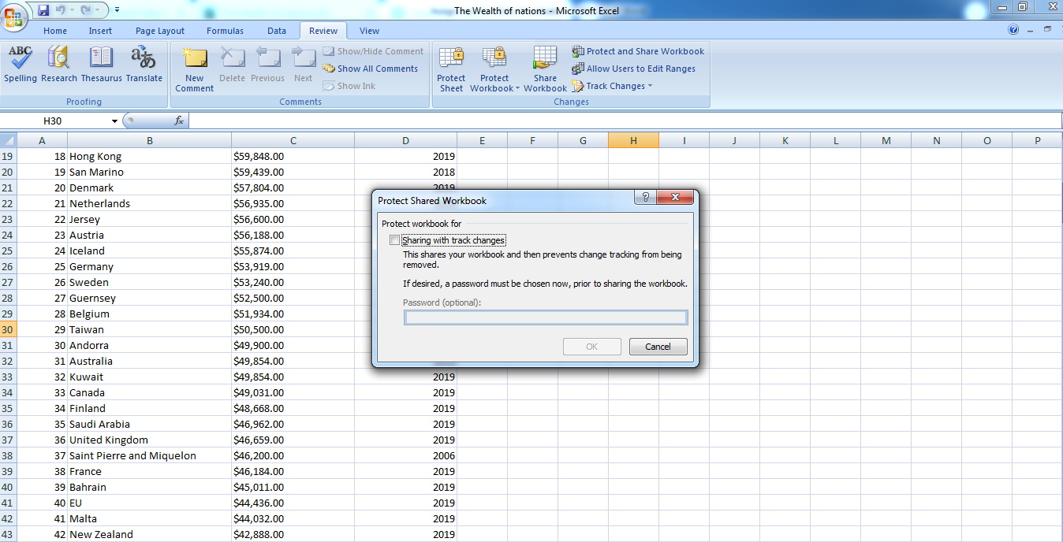

1. Another window pop up, just follow instruction i.e. renter password.

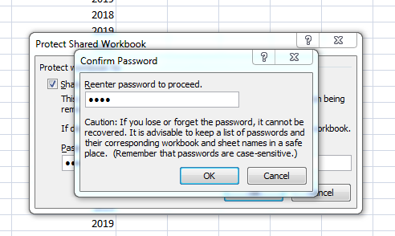

1. Before continuing, it will confirm again. Just click OK to save protected workbook.

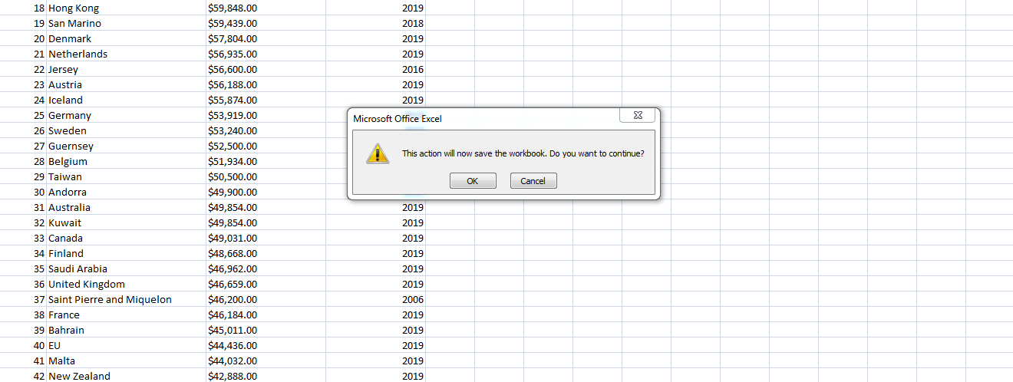

## Highlighting and change the data in £

1. Select column C by clicking on it (header where is C is writing).
2. Then select 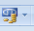 under 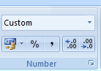 under home.



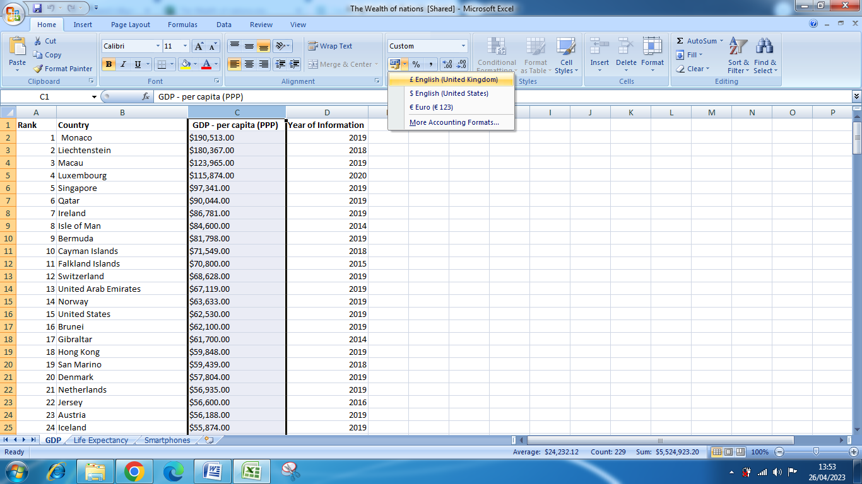

1. In the drop down menu, click on British Pound symbol. Now column C values will change to British Pound.

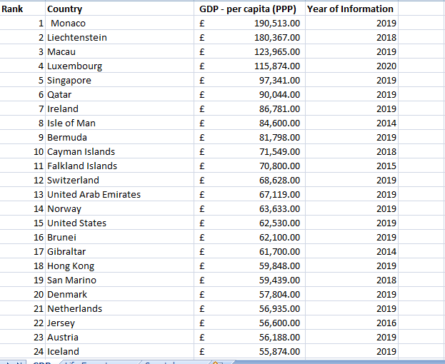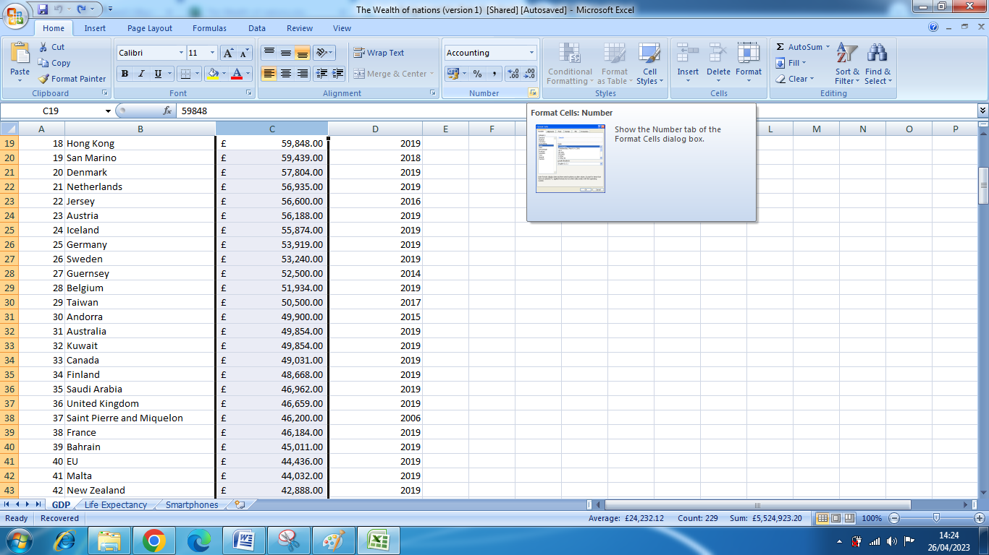

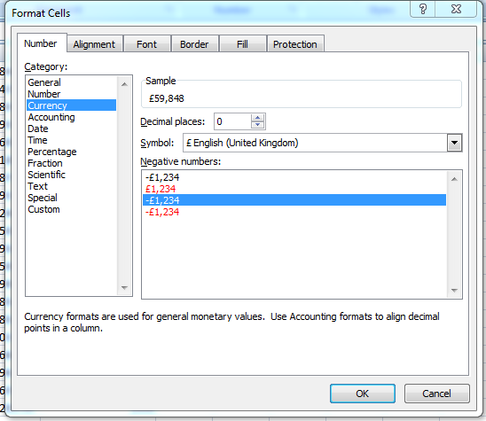

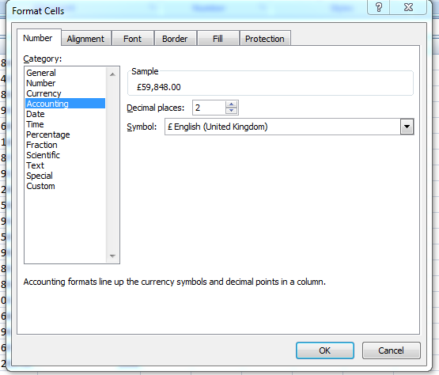

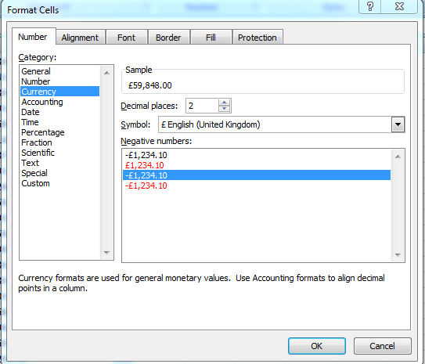

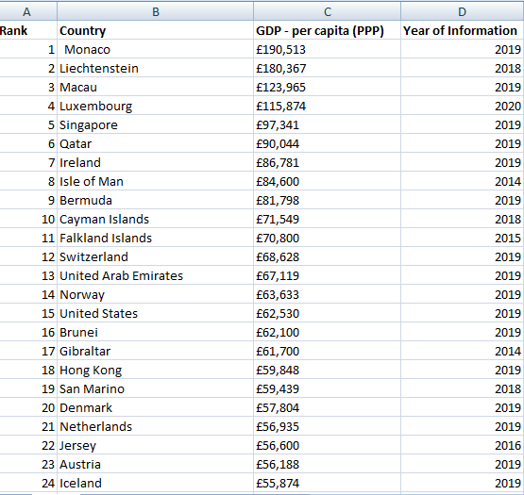

#### Turning the GDP sheet into table

1. For turning the GDP sheet into table, we have to unprotect this workbook first.

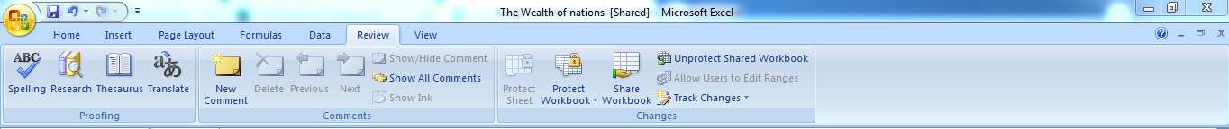

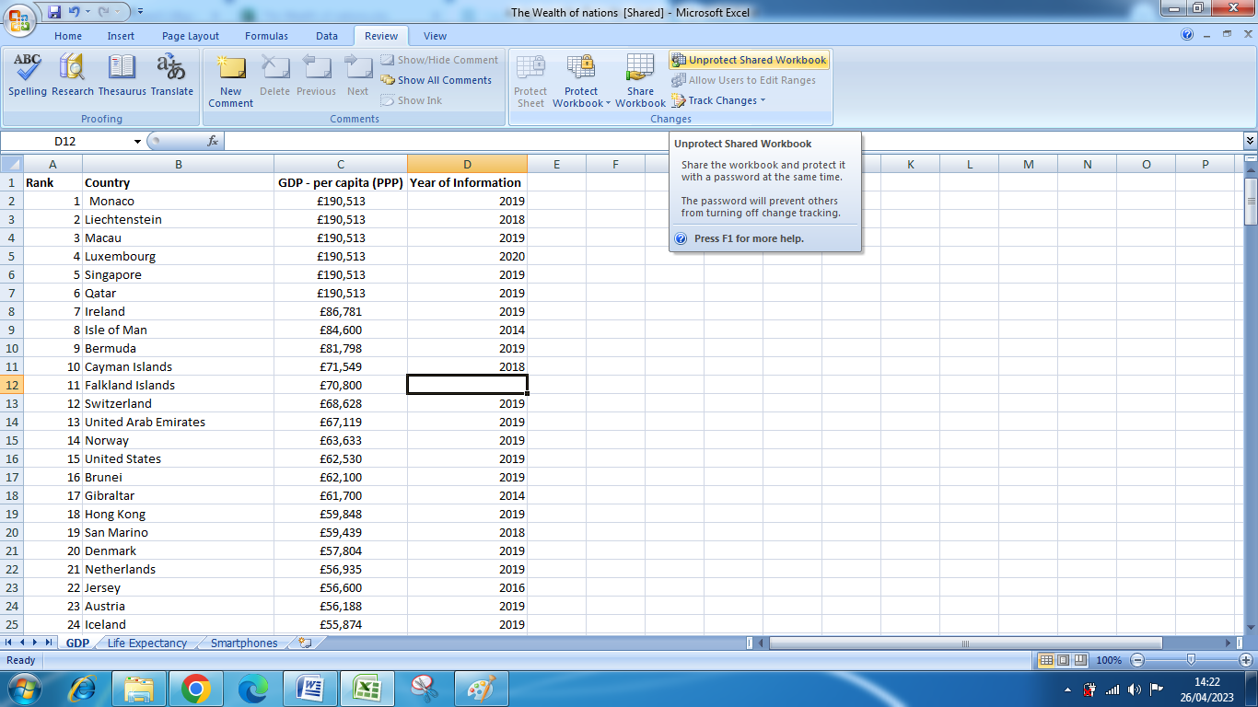

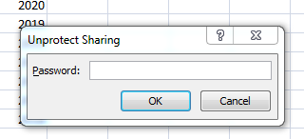

Excel will refresh itself or start again.

1. Make sure that you have selected a range of cells that contains data. The "Format as Table" option will not be available if you have selected a blank cell or range of cells.
2. Ensure that the range of cells you have selected does not include merged cells. Excel cannot format a range of merged cells as a table
3. Check that the range of cells you have selected does not overlap with any other tables or objects on the sheet.

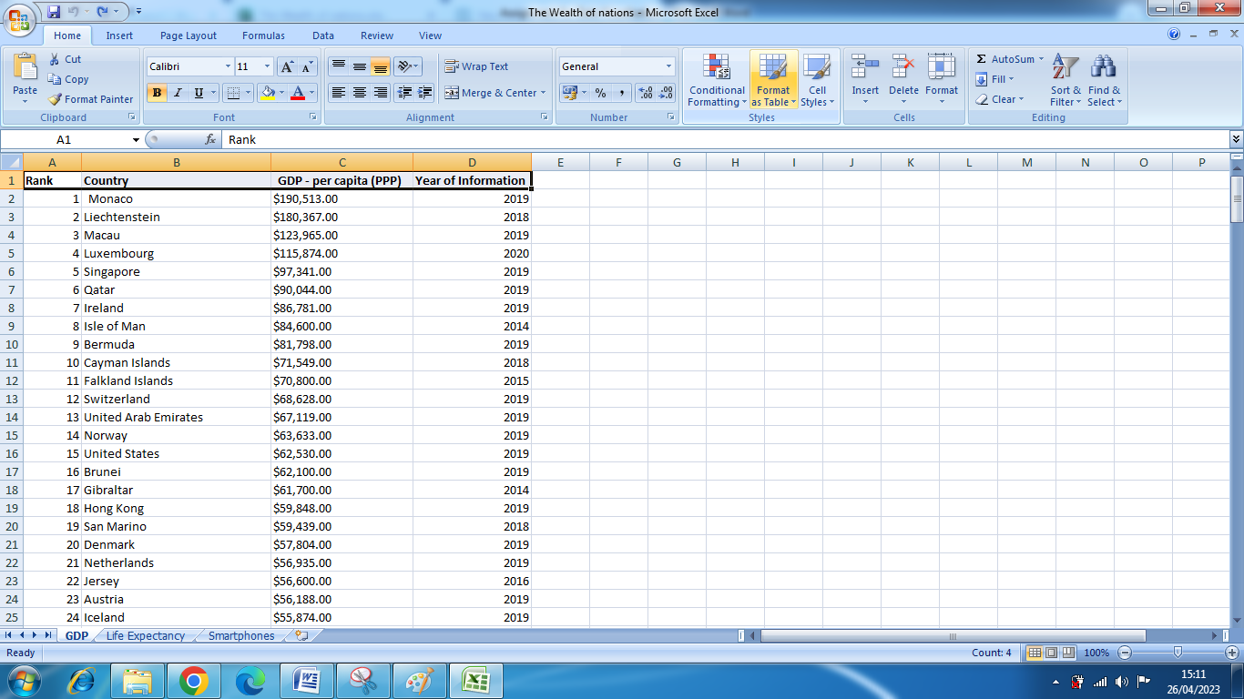

1. Then click on **FORMAT INTO TABLE** in **HOM**E tab.

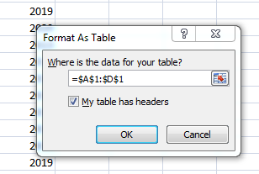

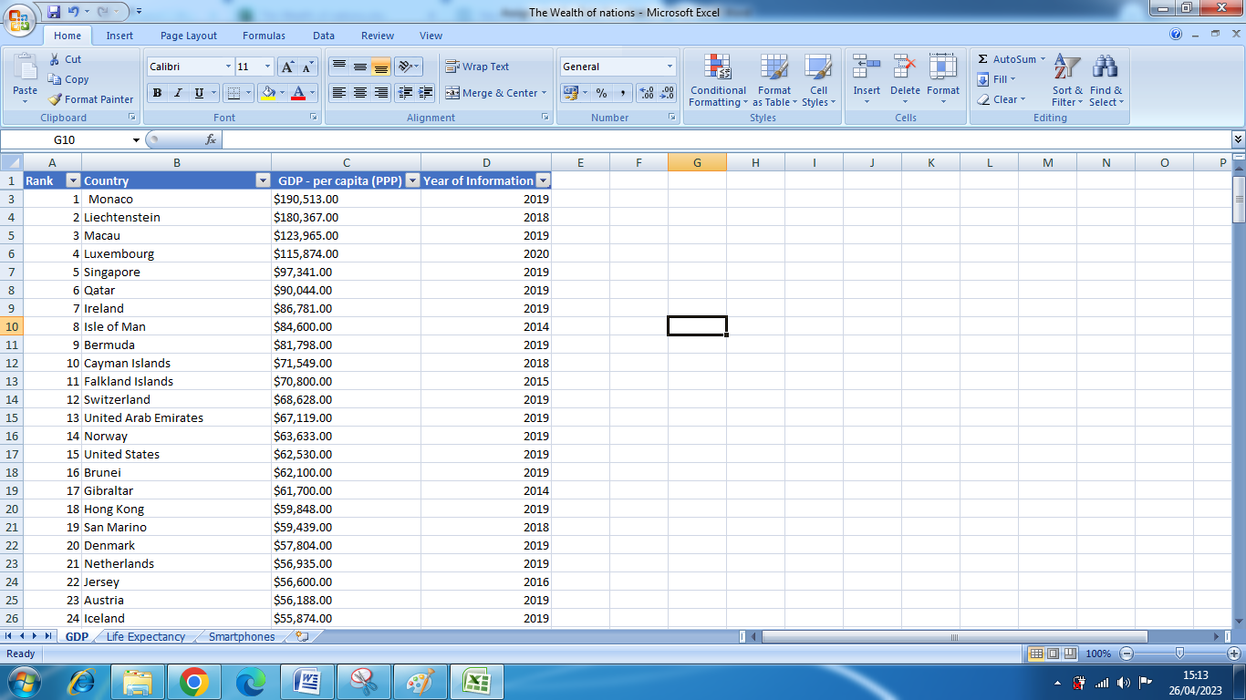

1. **Filter 2019 Information**
2. Click on Year of Information.
3. Open drop down menu.
4. Unselect all year.
5. Select only 2019 and click OK.

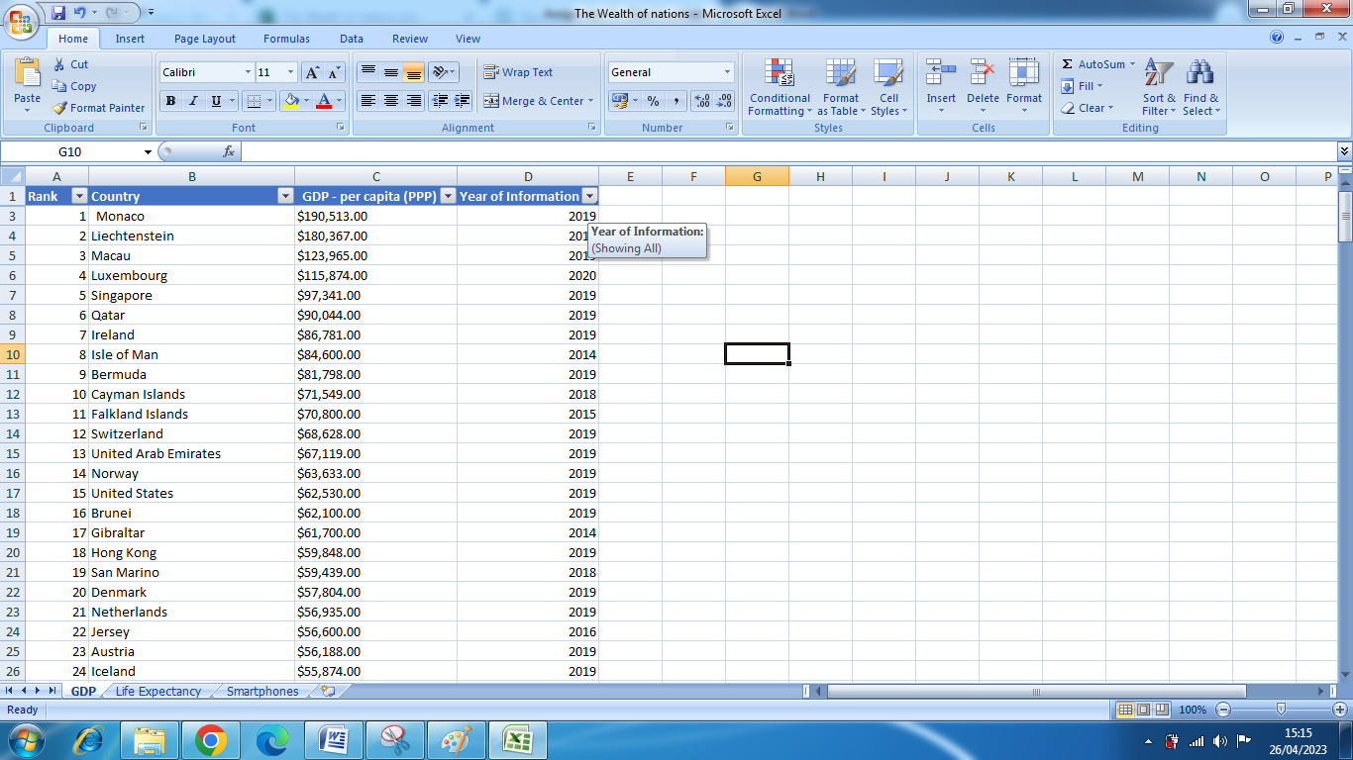

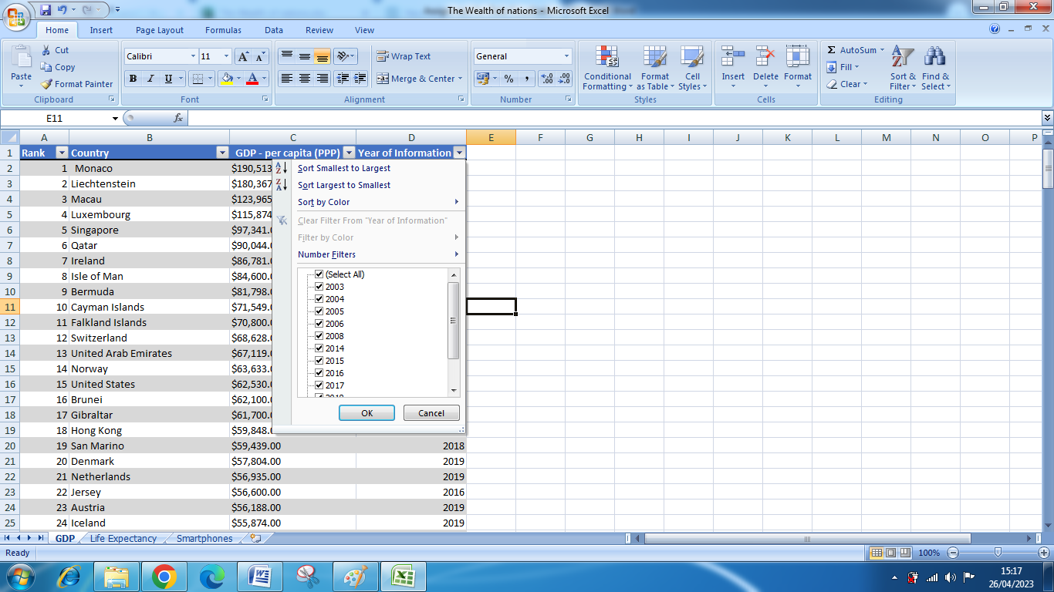



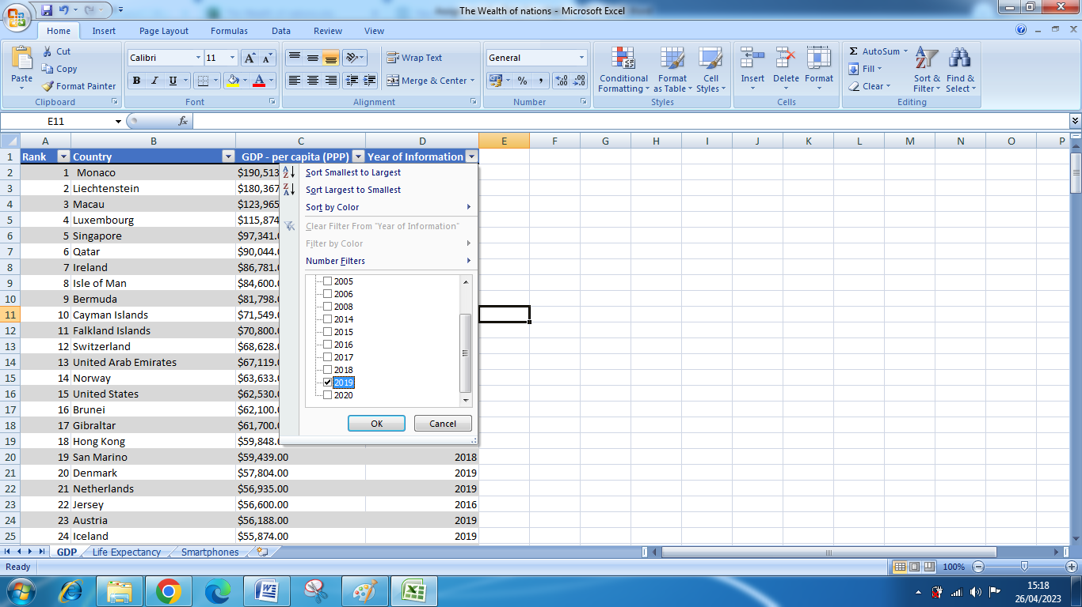

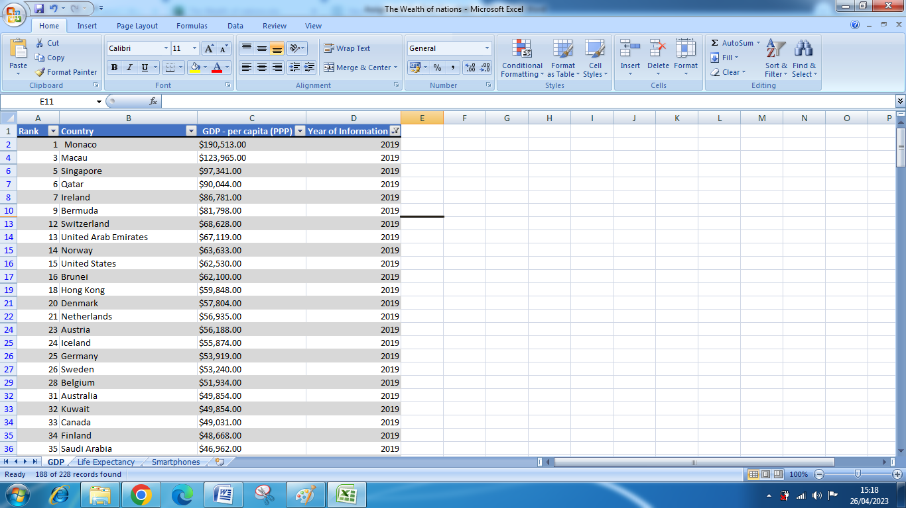

## Chart; Rank, Country and GDP

1. Select range for which chart have to make.
2. Go to insert tab on ribbon.
3. Choose the chart.

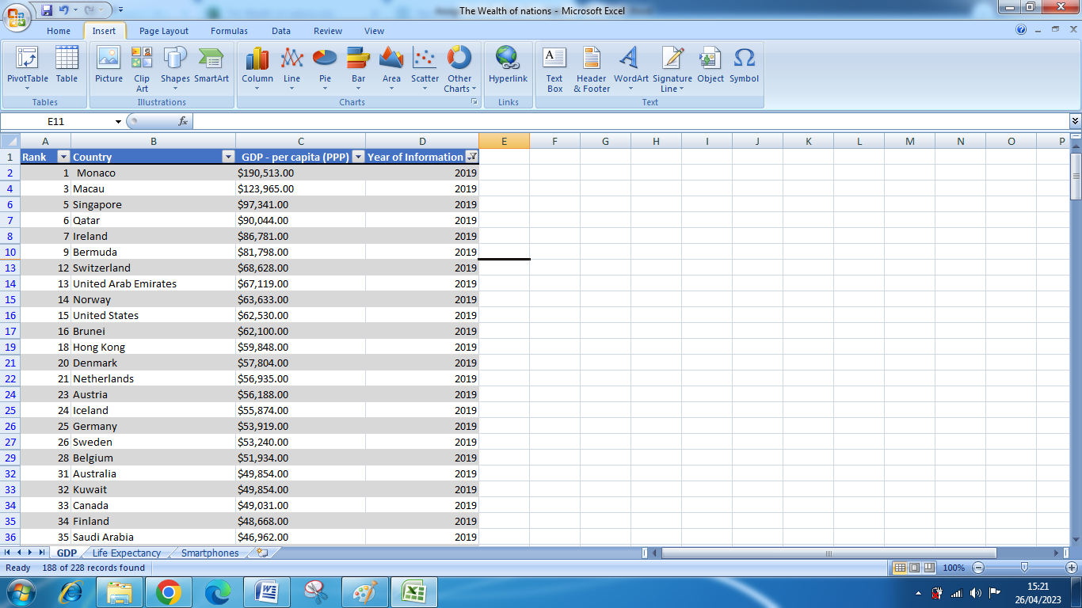

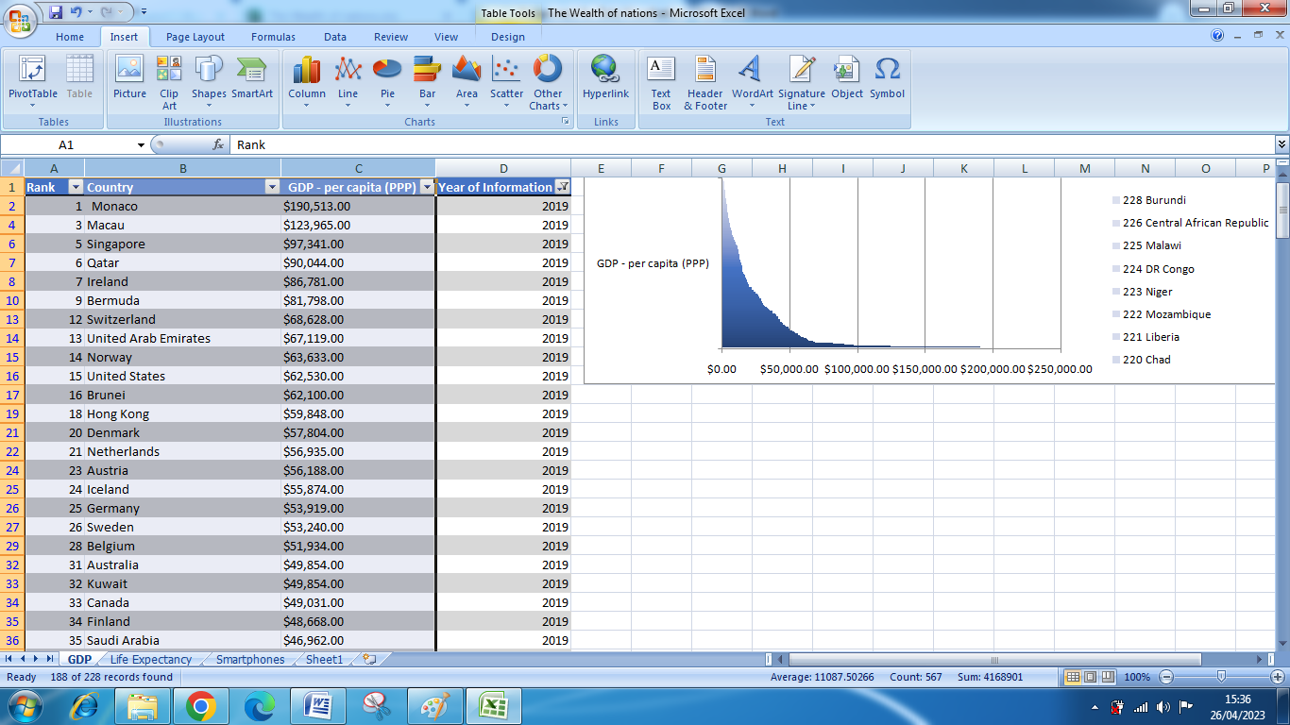

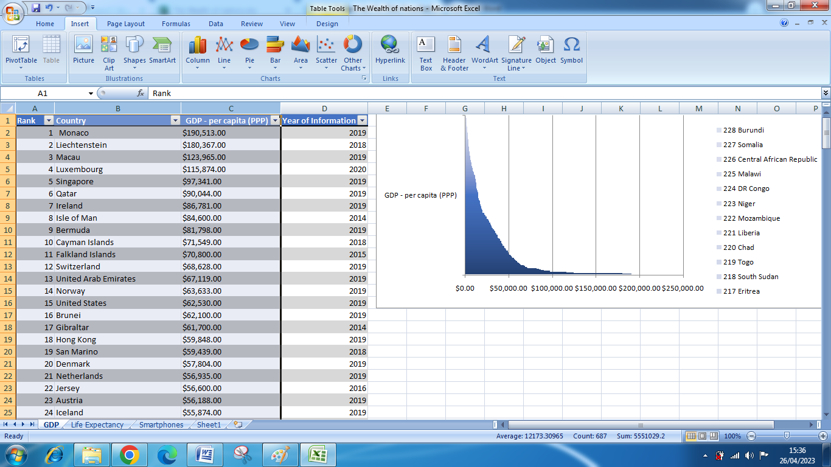

## Edit the Chart.

### Add title

1. Click on table
2. Select layout.
3. Click ADD TITLE on ribbon.

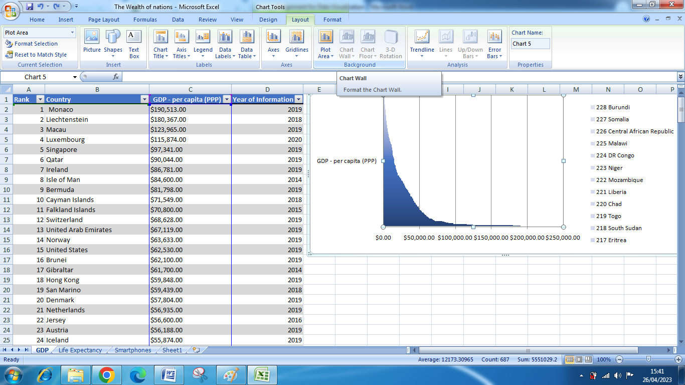

1. Click on **chart title** button.

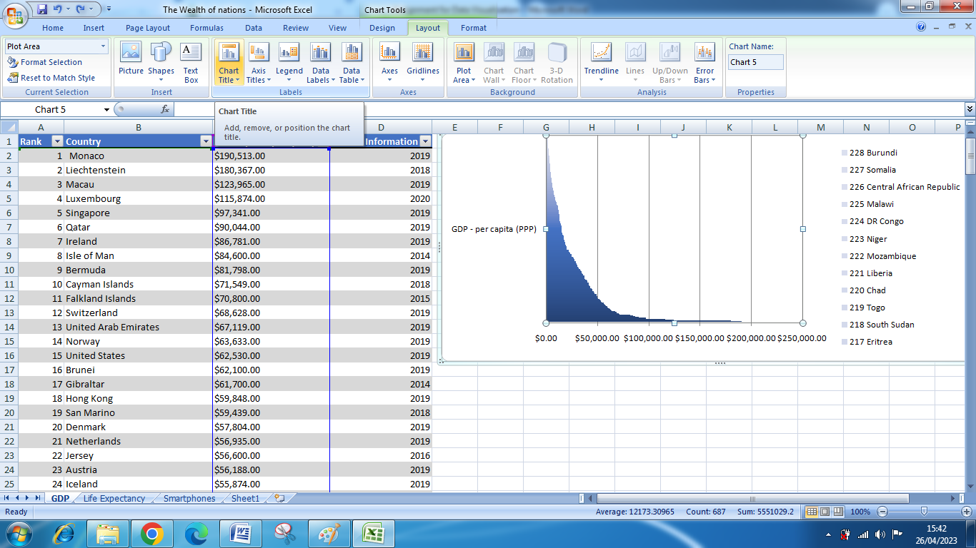

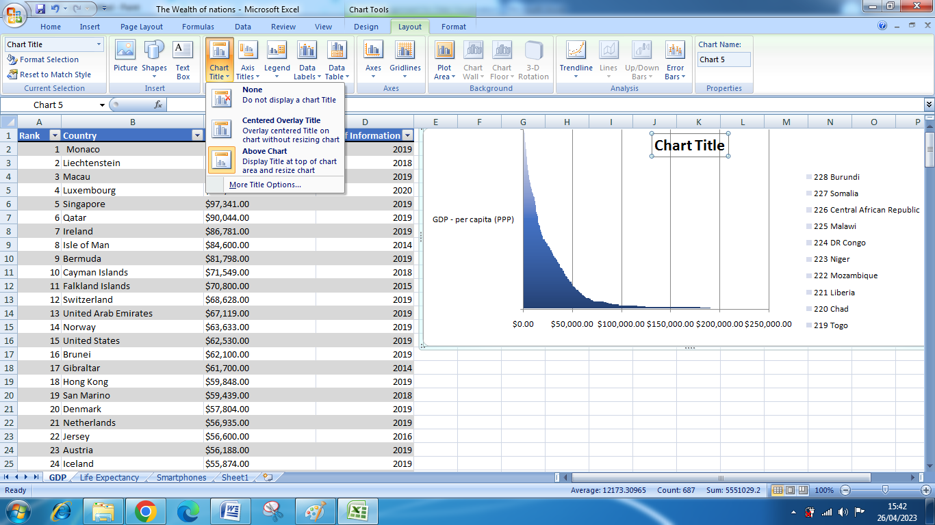

1. Give appropriate name

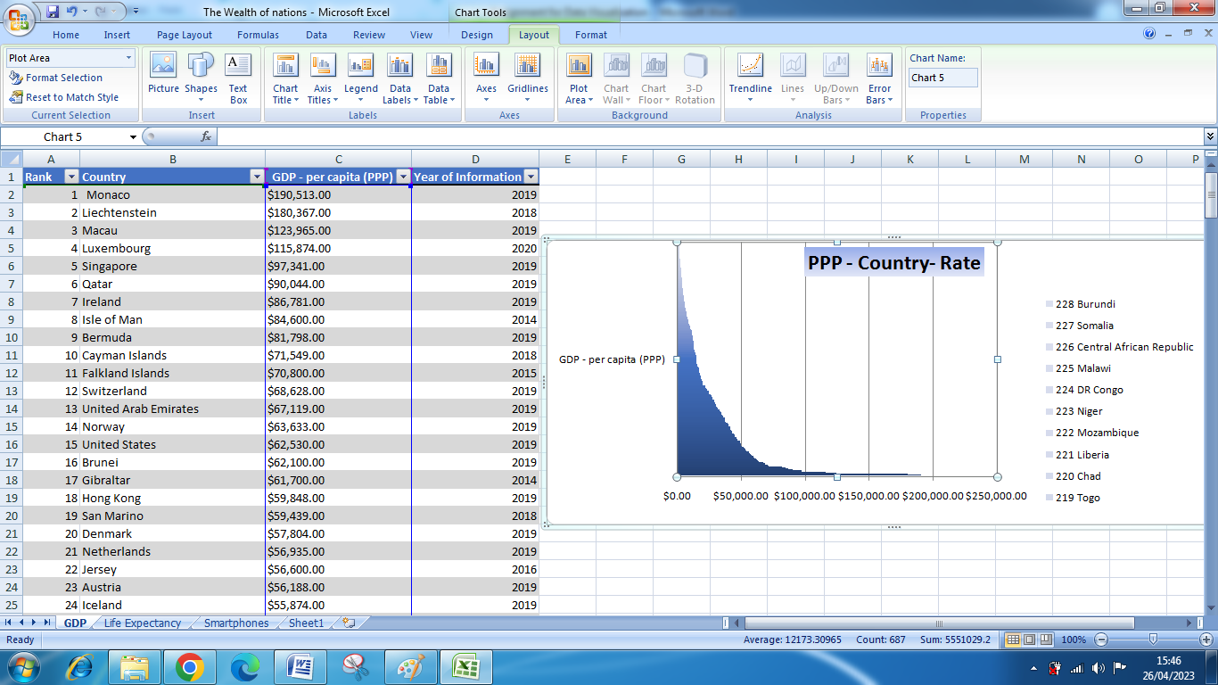

### Add X-axis and Y-axis labels

1. Next to ADD TITLE , there is **AXIS TITLE**, by clicking then we can change both x-axis and y-axis labels.

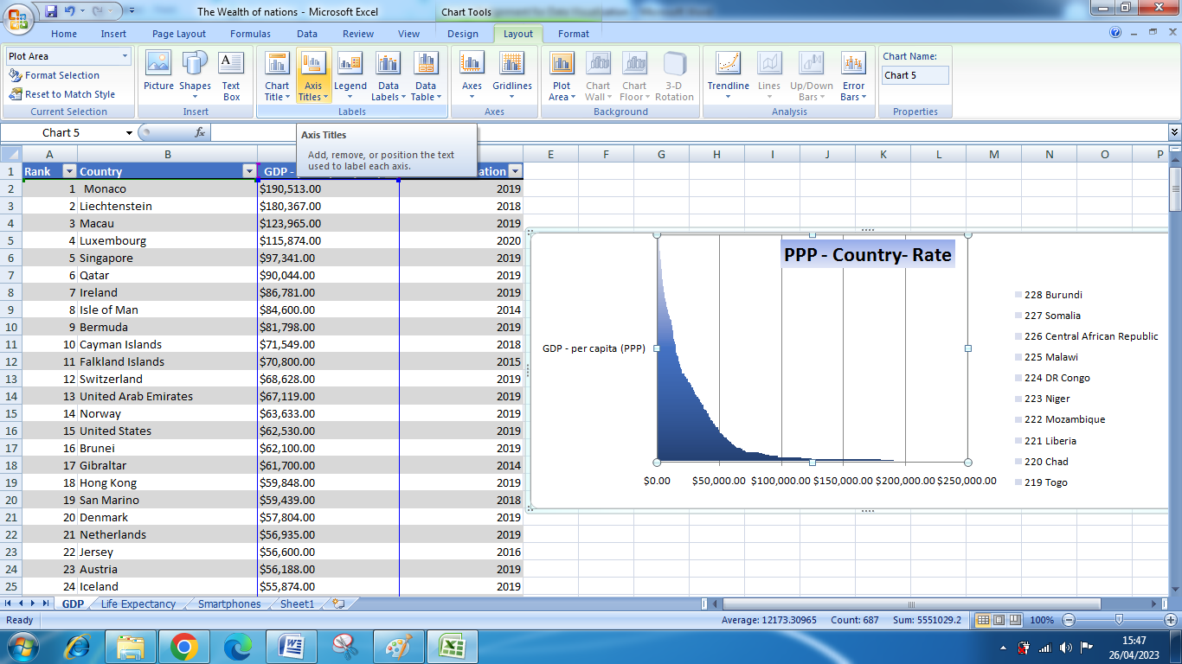

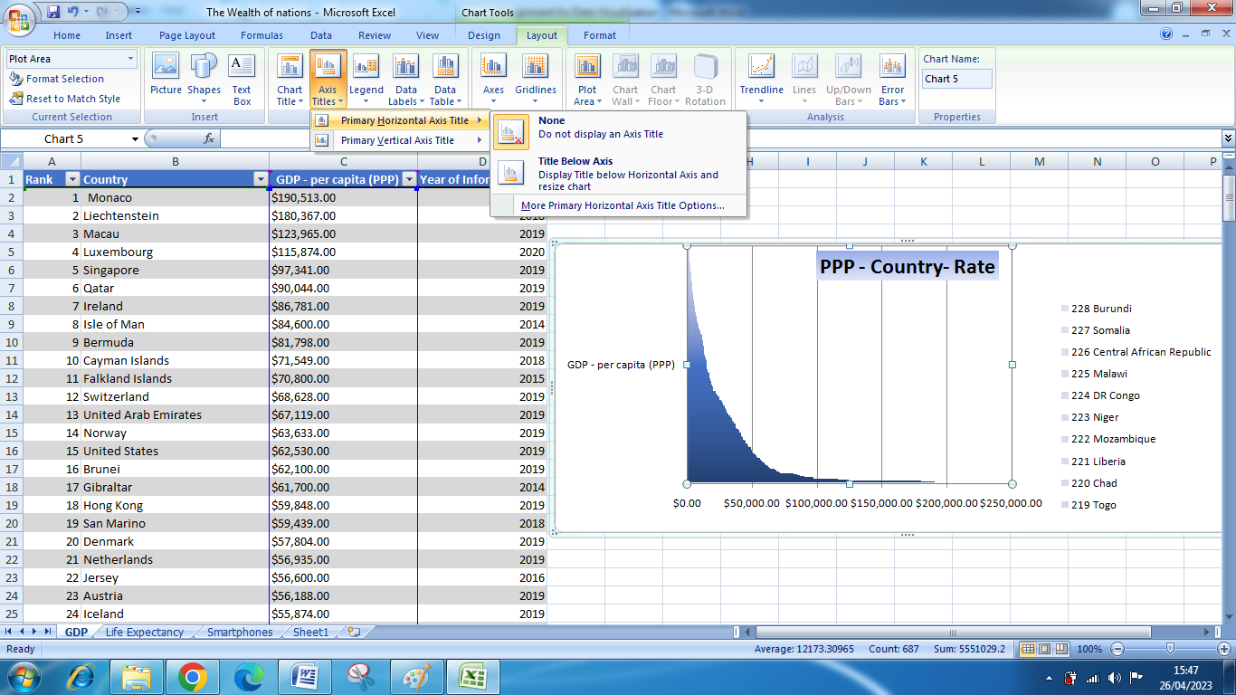

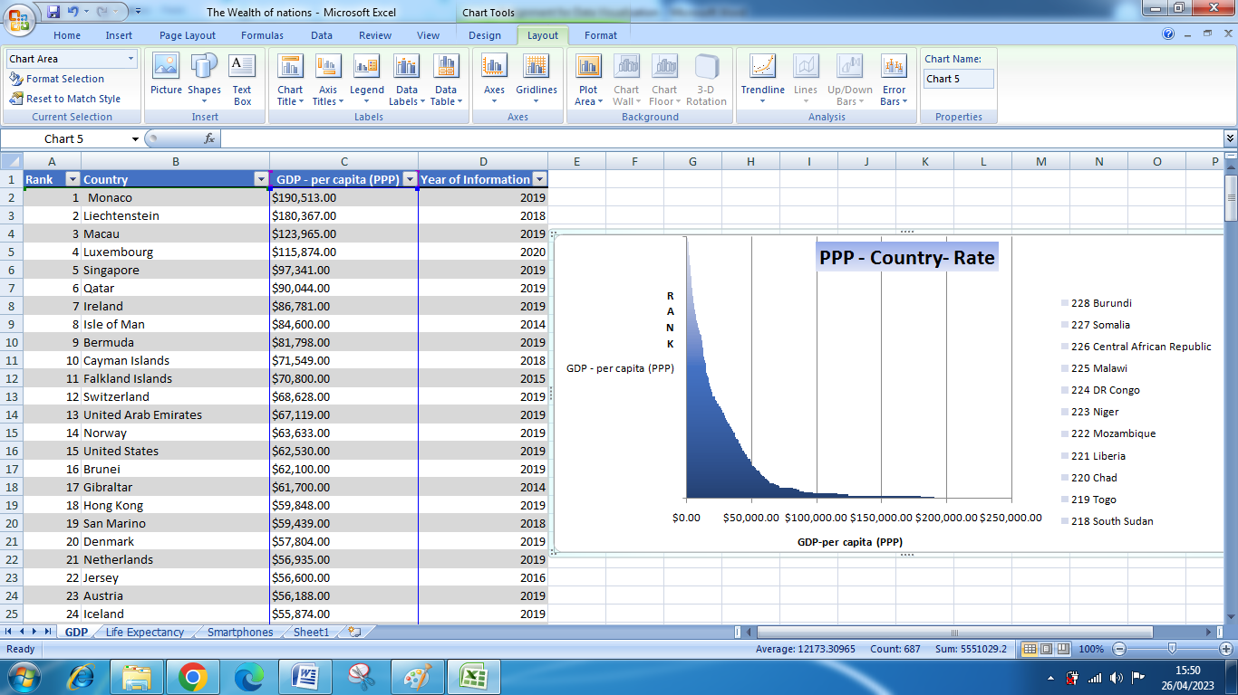

### Make Chart Visually Appealing

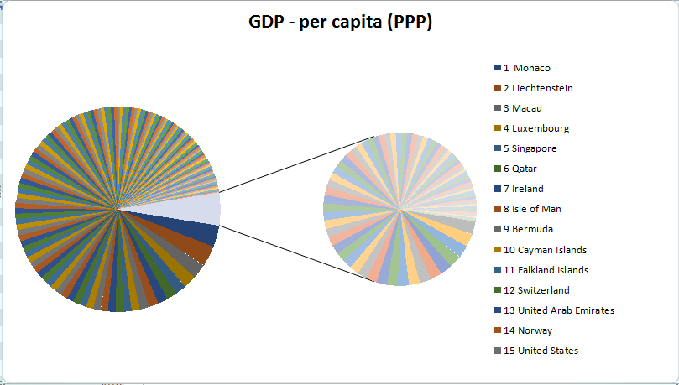

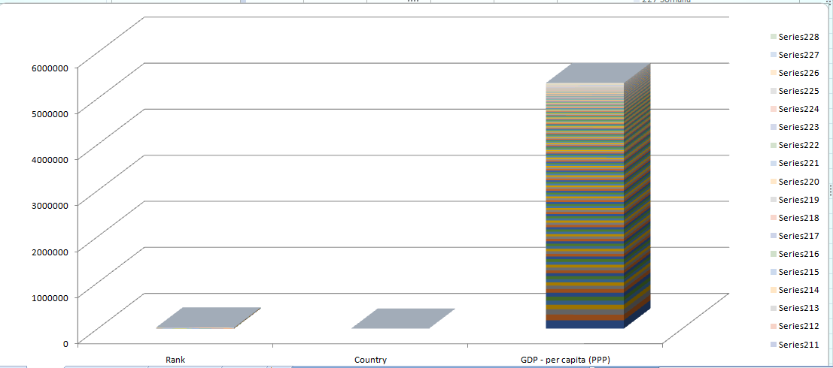

## Move the Chart to new Sheet and Named it

Click on chart then select design tab on ribbon there will be MOVE CHART option.

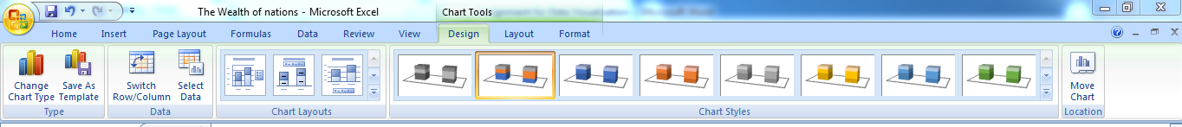

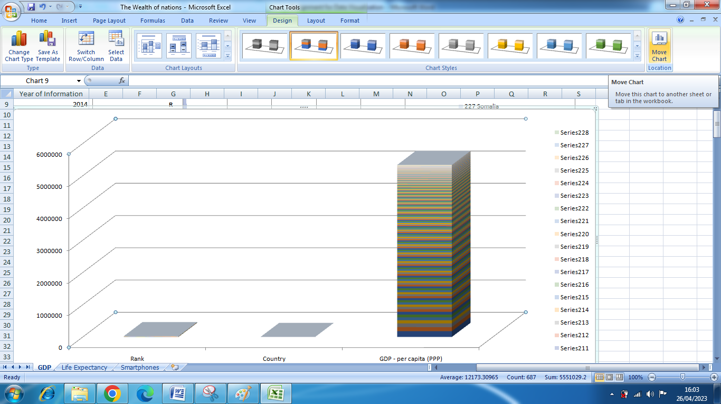

Click on move chart button there will open dialogue button, select new sheet.

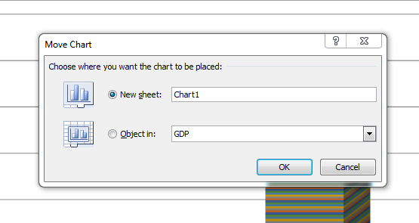

When you click on OK then it will move to new sheet.

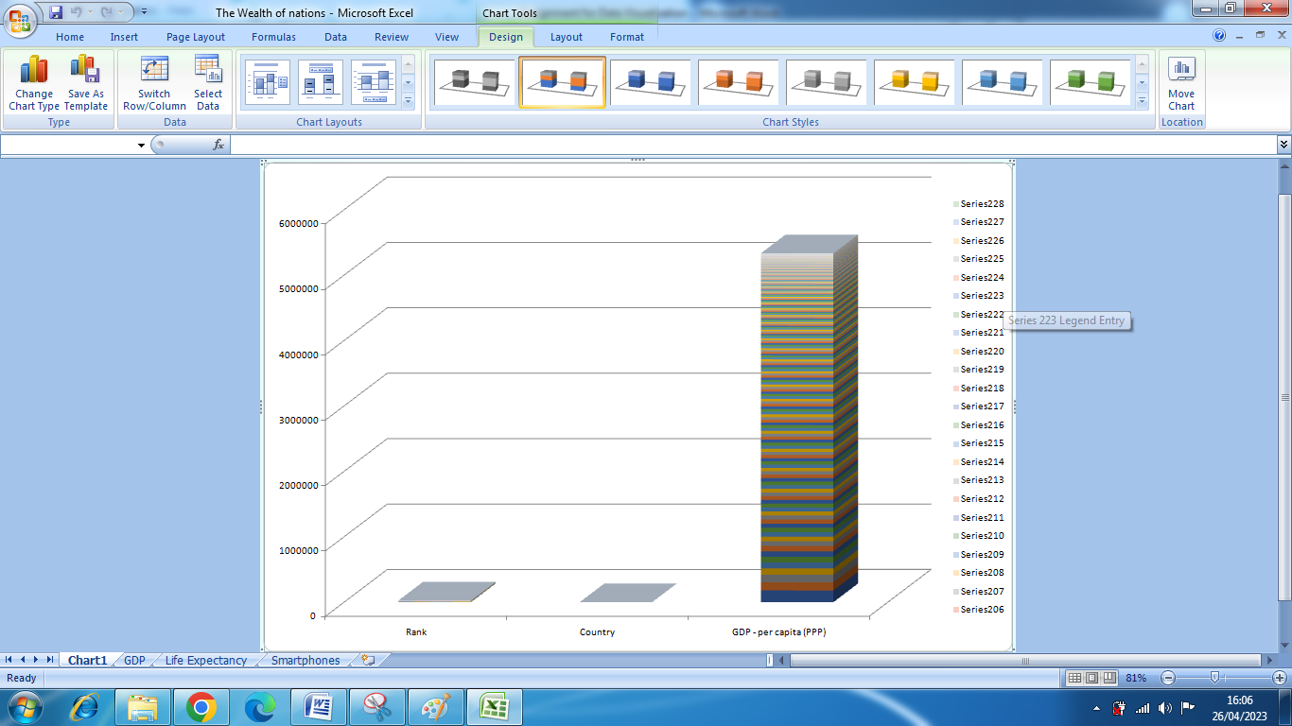

To label with name, right click on lower tab and select rename.

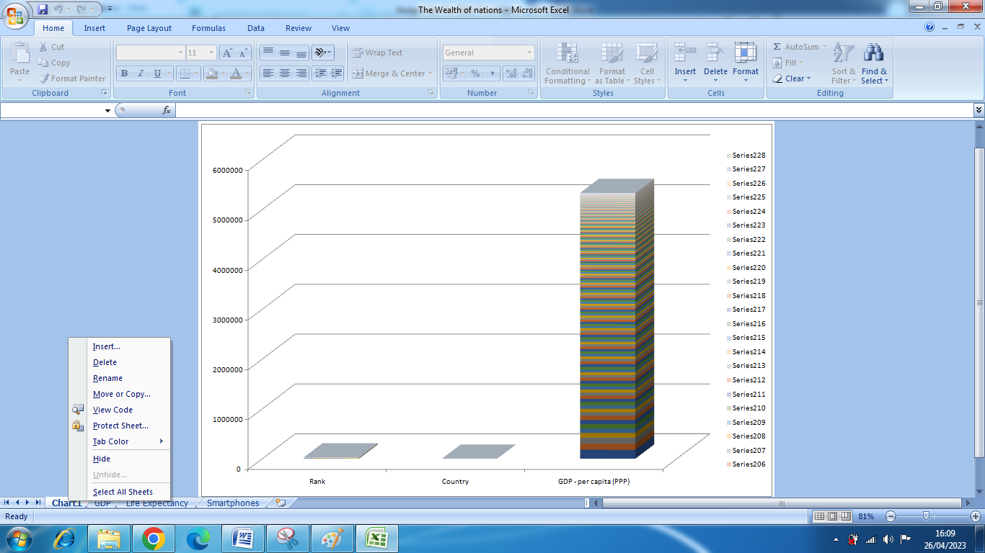

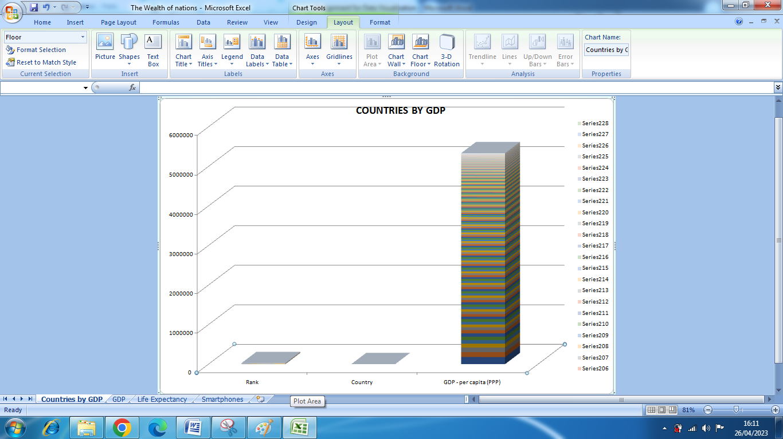

## TOP 20 Countries

1. Click on Rank header and open menu.
2. Deselect all number from filter.
3. Select top 20 and click OK.

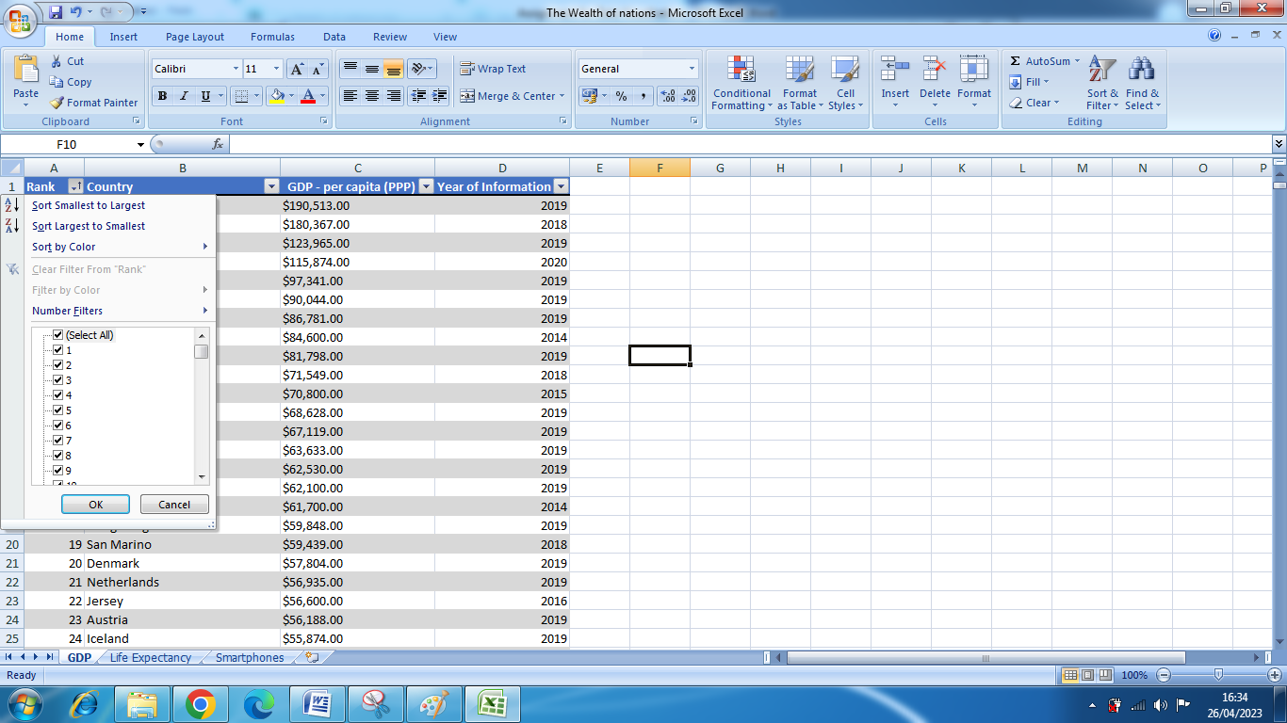

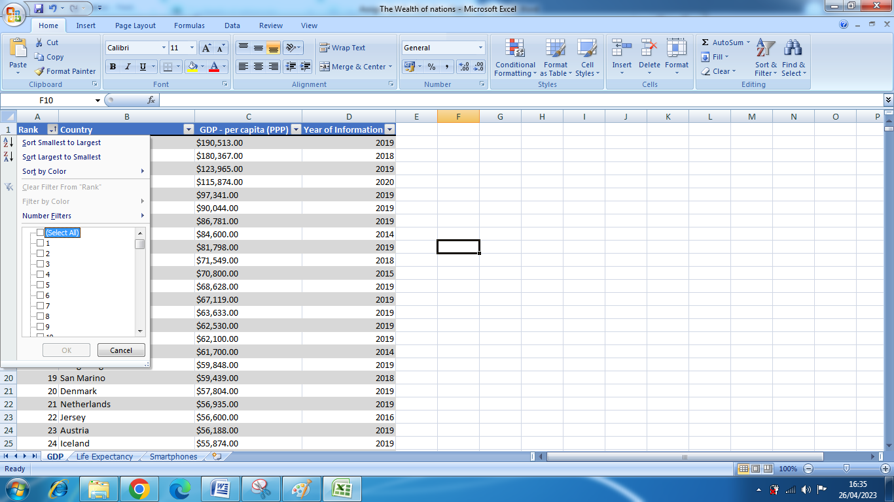

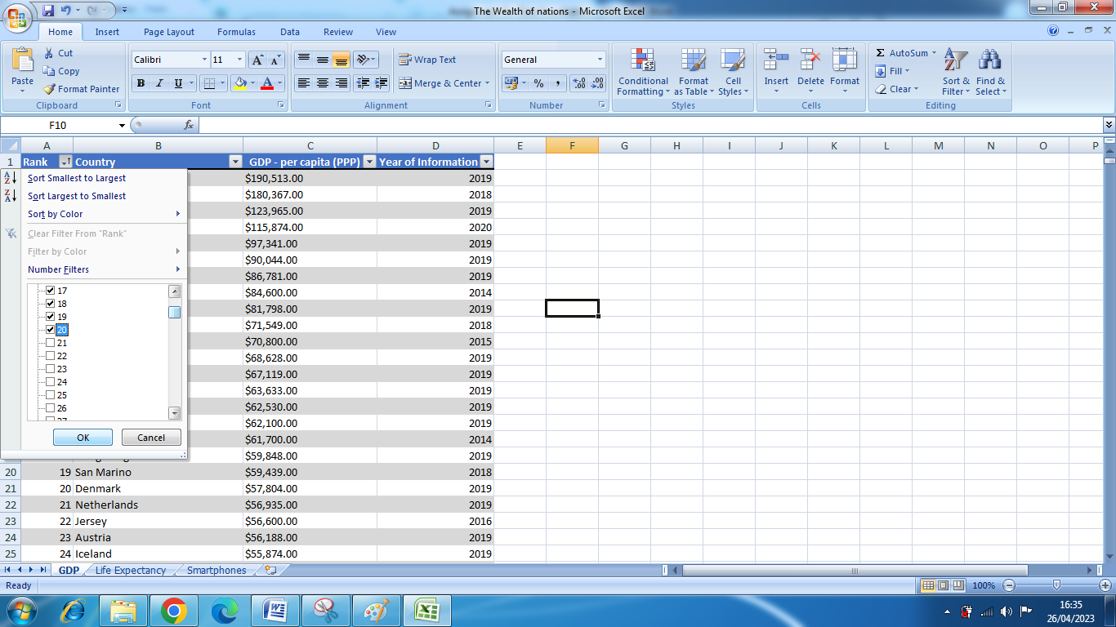

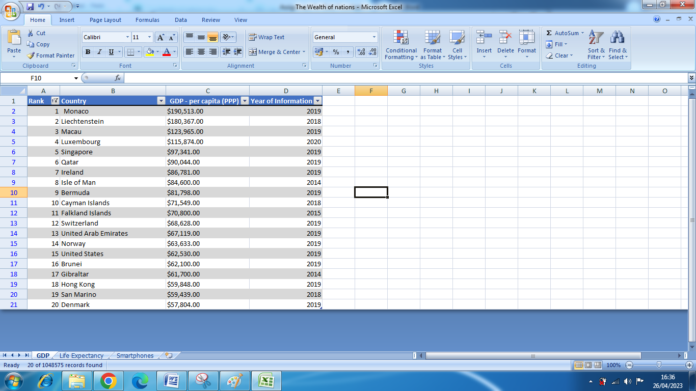

OR

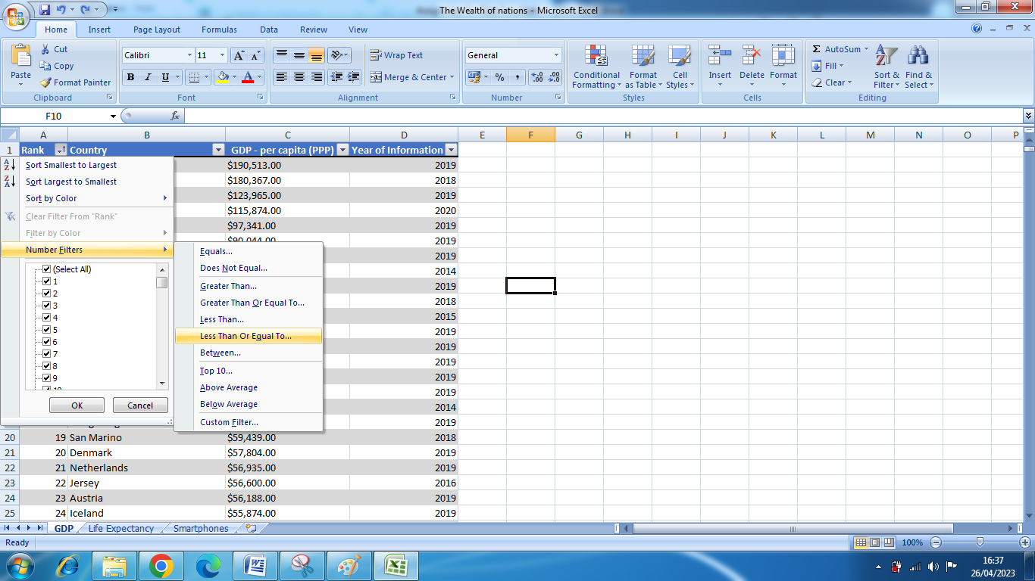

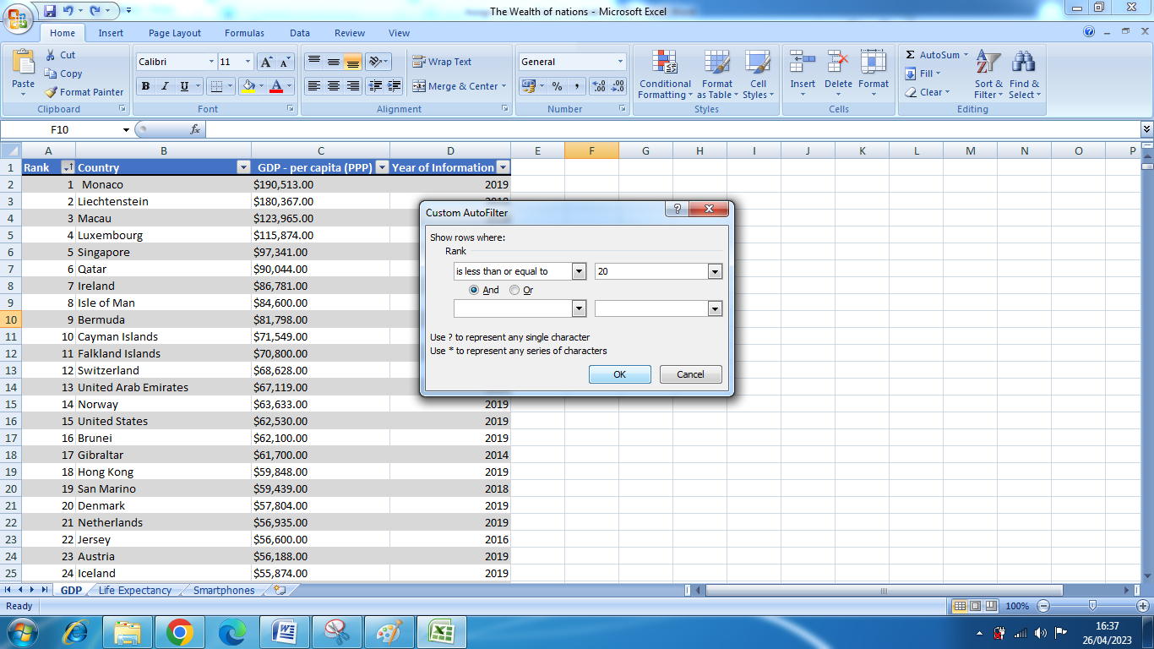

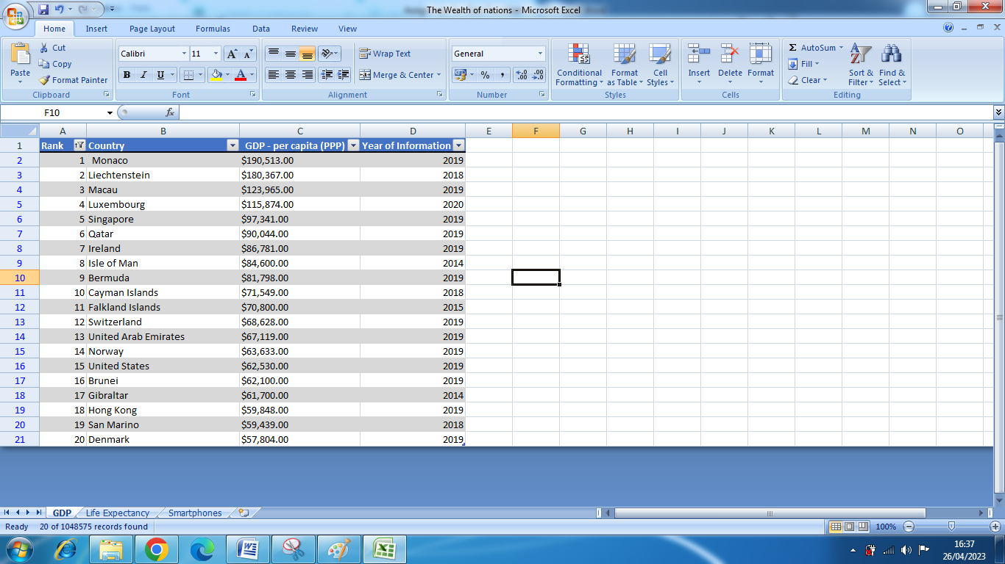

## Bar Chart

1. Apply sorting.
2. Copy data to new sheet.
3. Make new chart by selection data from header row.
4. Move chart to below data.

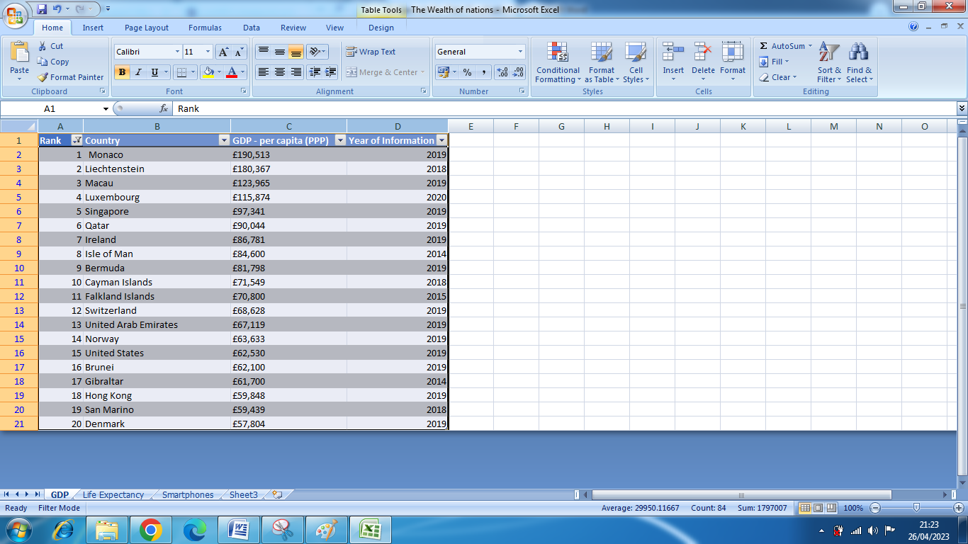

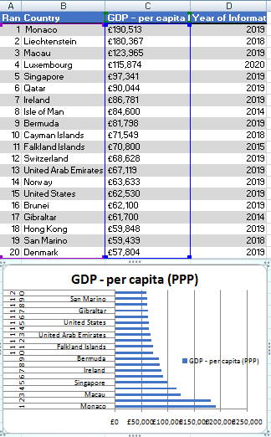

## Colouring

